# INTRODUCTION:

A blast furnace is a type of metallurgical furnace used for smelting to produce industrial metals, generally iron, but also others such as lead or copper. In a blast furnace, fuel, ores, and flux (limestone) are continuously supplied through the top of the furnace, while a hot blast of air (sometimes with oxygen enrichment) is blown into the lower section of the furnace through a series of pipes called tuyeres, so that the chemical reactions take place throughout the furnace as the material moves downward. The end products are usually molten metal and slag phases tapped from the bottom, and flue gases exiting from the top of the furnace. The downward flow of the ore and flux in contact with an up flow of hot, carbon monoxide-rich combustion gases is a counter current exchange and chemical reaction process.

Instrumentation maintenance steer with an objective to monitor and control the Blast Furnace process plant and its accessories. Instrumentation ensures that the plant operates within defined parameters to produce materials of consistent quality and within the required specifications. It also ensures that the plant is operated safely and acts to correct out of tolerance operation and to automatically shut down the plant to prevent hazardous conditions from occurring. Instrumentation comprises PLC Controllers, Scada, Flow, Pressure, Temp sensor elements, signal transmitters, controllers, indicators and alarms, actuated valves, logic circuits and operator interfaces.  
The department works alongside various other departments such as electrical, Mechanical, projects and business excellence for taking innovative & automated approach that further enhances the system. Innovation, kaizen, latest maintenance strategies, spares management are few of the primary pillars of the department.

Further with our various maintenance activities and total employee involvement, we are set to attain focused results in our employee orientation, customer orientation, shareholder and other stake holder orientations.

**MAINTENANCE.OBJECTIVES**

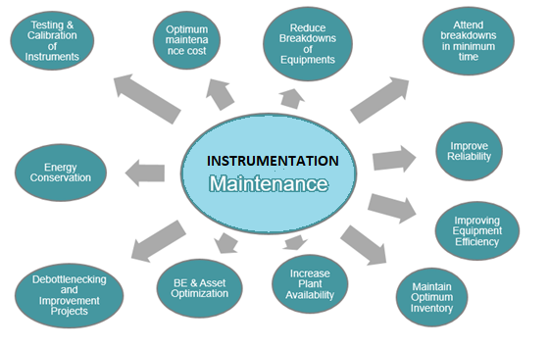

|  |  |  |
| --- | --- | --- |
| **Prepared By:**  Head Instrumentation PID-1 | **Reviewed & Issued By:**  Management Representative | **Approved By:**  Head – Electrical & Instrumentation PID I |
| **Signature** | **Signature:** | **Signature:** |
| **Review Date: 13.09.2023** | **Review Date: 13.09.2023** | **Review Date: 13.09.2023** |